15th Sunday in Ordinary Time
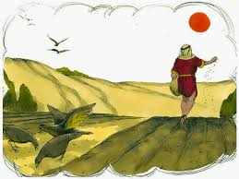

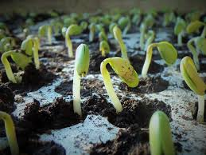
First Reading: Isaiah 55:10-11
For as the rain and the snow come down from heaven, and do not return there until they have watered the earth, making it bring forth and sprout, giving seed to the sower and bread to the eater, so shall my word be that goes out from my mouth; it shall not return to me empty, but it shall accomplish that which I purpose, and succeed in the thing for which I sent it.

Responsorial Psalm: Psalm 64:10-14
Response: The seed that falls on good ground will yield a fruitful harvest
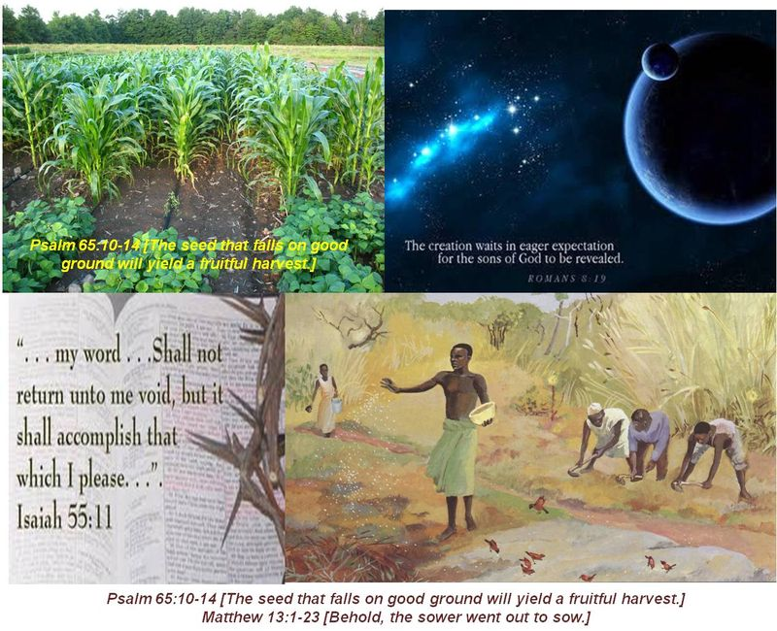
You care for the earth, give it water,
you fill it with riches.
Your river in heaven brims over
to provide its grain. Resp:
And thus you provide for the earth;
you drench its furrows,
you level it, soften it with showers,
you bless its growth. Resp:
You crown the year with your goodness.
Abundance flows in your steps,
in the pastures of the wilderness it flows. Resp:
The hills are girded with joy,
the meadows covered with flocks,
the valleys are decked with wheat,
They shout for joy, yes, they sing. Resp:

Second Reading: Romans 8:18-23
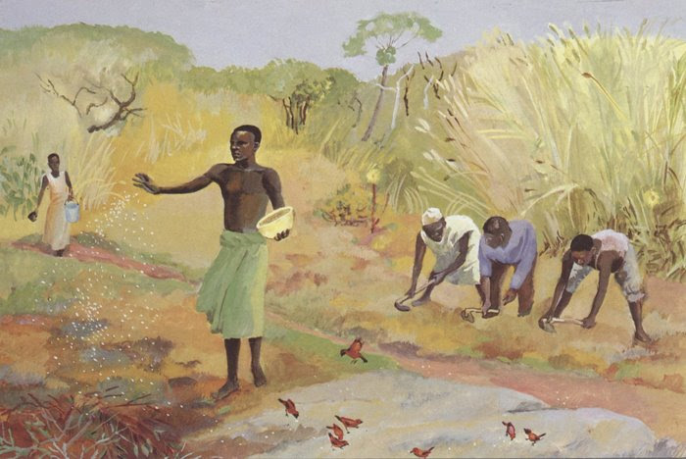
I consider that the sufferings of this present time are not worth comparing with the glory about to be revealed to us. For the creation waits with eager longing for the revealing of the children of God; for the creation was subjected to futility, not of its own will but by the will of the one who subjected it, in hope that the creation itself will be set free from its bondage to decay and will obtain the freedom of the glory of the children of God. We know that the whole creation has been groaning in labour pains until now; and not only the creation, but we ourselves, who have the first fruits of the Spirit, groan inwardly while we wait for adoption, the redemption of our bodies.
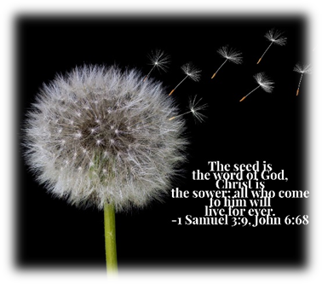
Gospel Acclamation:
Alleluia, alleluia !
The seed is the word of God, Christ is the sower;
All who come to him will live for ever

Alleluia !

Gospel: Matthew 13:1-23
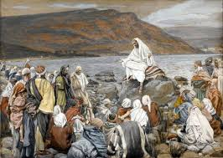

The Parable of the Sower

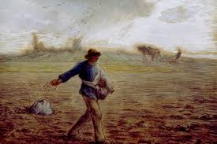
Jesus went out of the house and sat beside the sea. Such great crowds gathered around him that he got into a boat and sat there, while the whole crowd stood on the beach. And he told them many things in parables, saying: “Listen! A sower went out to sow. And as he sowed, some seeds fell on the path, and the birds came and ate them up. Other seeds fell on rocky ground, where they did not have much soil, and they sprang up quickly, since they had no depth of soil. But when the sun rose, they were scorched; and since they had no root, they withered away. Other seeds fell among thorns, and the thorns grew up and choked them. Other seeds fell on good soil and brought forth grain, some a hundredfold, some sixty, some thirty. Let anyone with ears listen!”
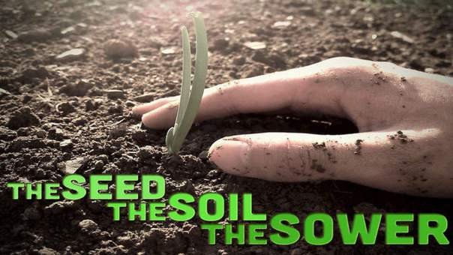
Then the disciples came and asked him, “Why do you speak to them in parables?” He answered, “To you it has been given to know the secrets of the kingdom of heaven, but to them it has not been given. For to those who have, more will be given, and they will have an abundance; but from those who have nothing, even what they have will be taken away. The reason I speak to them in parables is that ‘seeing they do not perceive, and hearing they do not listen, nor do they understand.’ With them indeed is fulfilled the prophecy of Isaiah that says: ‘You will indeed listen, but never understand, and you will indeed look, but never perceive. For this people’s heart has grown dull, and their ears are hard of hearing, and they have shut their eyes; so that they might not look with their eyes, and listen with their ears, and understand with their heart and turn-and I would heal them.’
“But blessed are your eyes, for they see, and your ears, for they hear. Truly I tell you, many prophets and righteous people longed to see what you see, but did not see it, and to hear what you hear, but did not hear it.
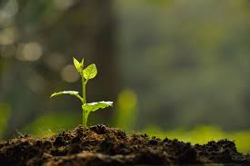
“Hear then the parable of the sower. When anyone hears the word of the kingdom and does not understand it, the evil one comes and snatches away what is sown in the heart; this is what was sown on the path. As for what was sown on rocky ground, this is the one who hears the word and immediately receives it with joy; yet such a person has no root, but endures only for a while, and when trouble or persecution arises on account of the word, that person immediately falls away. As for what was sown among thorns, this is the one who hears the word, but the cares of the world and the lure of wealth choke the word, and it yields nothing. But as for what was sown on good soil, this is the one who hears the word and understands it, who indeed bears fruit and yields, in one case a hundredfold, in another sixty, and in another thirty.”

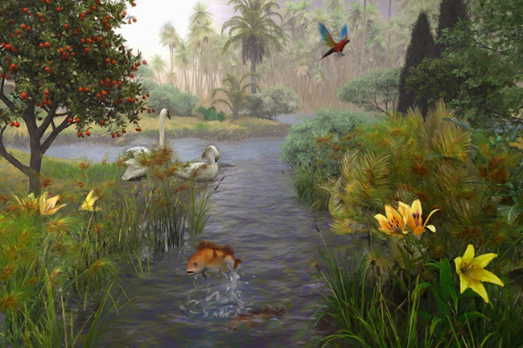
Reflections:
We have heard the strong metaphor about how the rain and snow, falling from the sky and soaking the earth, then rise towards heaven as plants, flowers and trees. Divine inspiration is the rain and snow, our inspired lives are the blossoming plants. This image concludes the great section of Isaiah 40-55, some of the most sublime literature of the Old Testament. He has the highest of hopes for the future of humanity
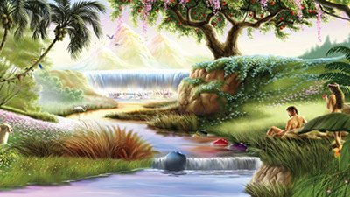
St Paul , in explaining the privileges conferred on by grace, has declared that we are given the spirit of adoption, and are given the spirit of heirs and joint heirs with Christ. He adds a qualifying phrase, “provided that we suffer with him, that we may be also glorified with him.” In the following verse, from today’s second Reading, St Paul estimates that it will all have been well worthwhile. “I reckon that the sufferings of this present time are not worthy to be compared with the glory which shall be revealed to us.” By the gift of the Spirit and the operations of the Spirit in renewing human beings from the inside out, when God gives us our resurrected bodies, we shall reflect the likeness of Christ. He will be the Firstborn, the elder Brother in the family, all of which bear His image.
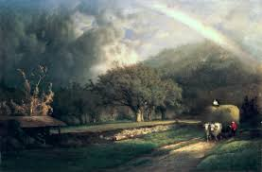
But is that all God’s willed to do: put a perfected humanity into a blighted creation? There would be a constant clash between restored humanity and un-restored creation! So, our Creator has set his heart not only on this marvelous renewal of rebellious mankind, but of the whole of creation. Where St Paul says “I reckon,” this is his sober, reflective conclusion. This is not a transient, capricious thought he had in a moment of heightened, emotional fervor. This is his sober, reflective judgment: “That the sufferings of the present time (that believers have to bear in union with Christ) are not worthy to be compared with the glory which shall be revealed to us.” Our present sufferings will pale away in the light of the glory that is to be ours.
Then in trying to describe that glory, St Paul’s focus shifts. The whole of creation is contributing to our spiritual fulfilment. “For the earnest expectation of the creation waits for the revealing of the children of God.” In other words, the children of God will be shown for who they really are, God’s precious ones, intended to perfectly reflect the likeness of Christ with perfected spirits and risen, glorified bodies that will share the very life of our Lord’s glory.
